Course: ITD 2343 OOP Using C# Grade **_______**

Instructor: Mark Pranger

Student Name: Cristhian Carcamo

Due Date: 3/5/2025

Gradebook Comments: Copy the Gradebook comments and paste them here

## Lab Portion Section 2 Exam – Carcamo

## Before run

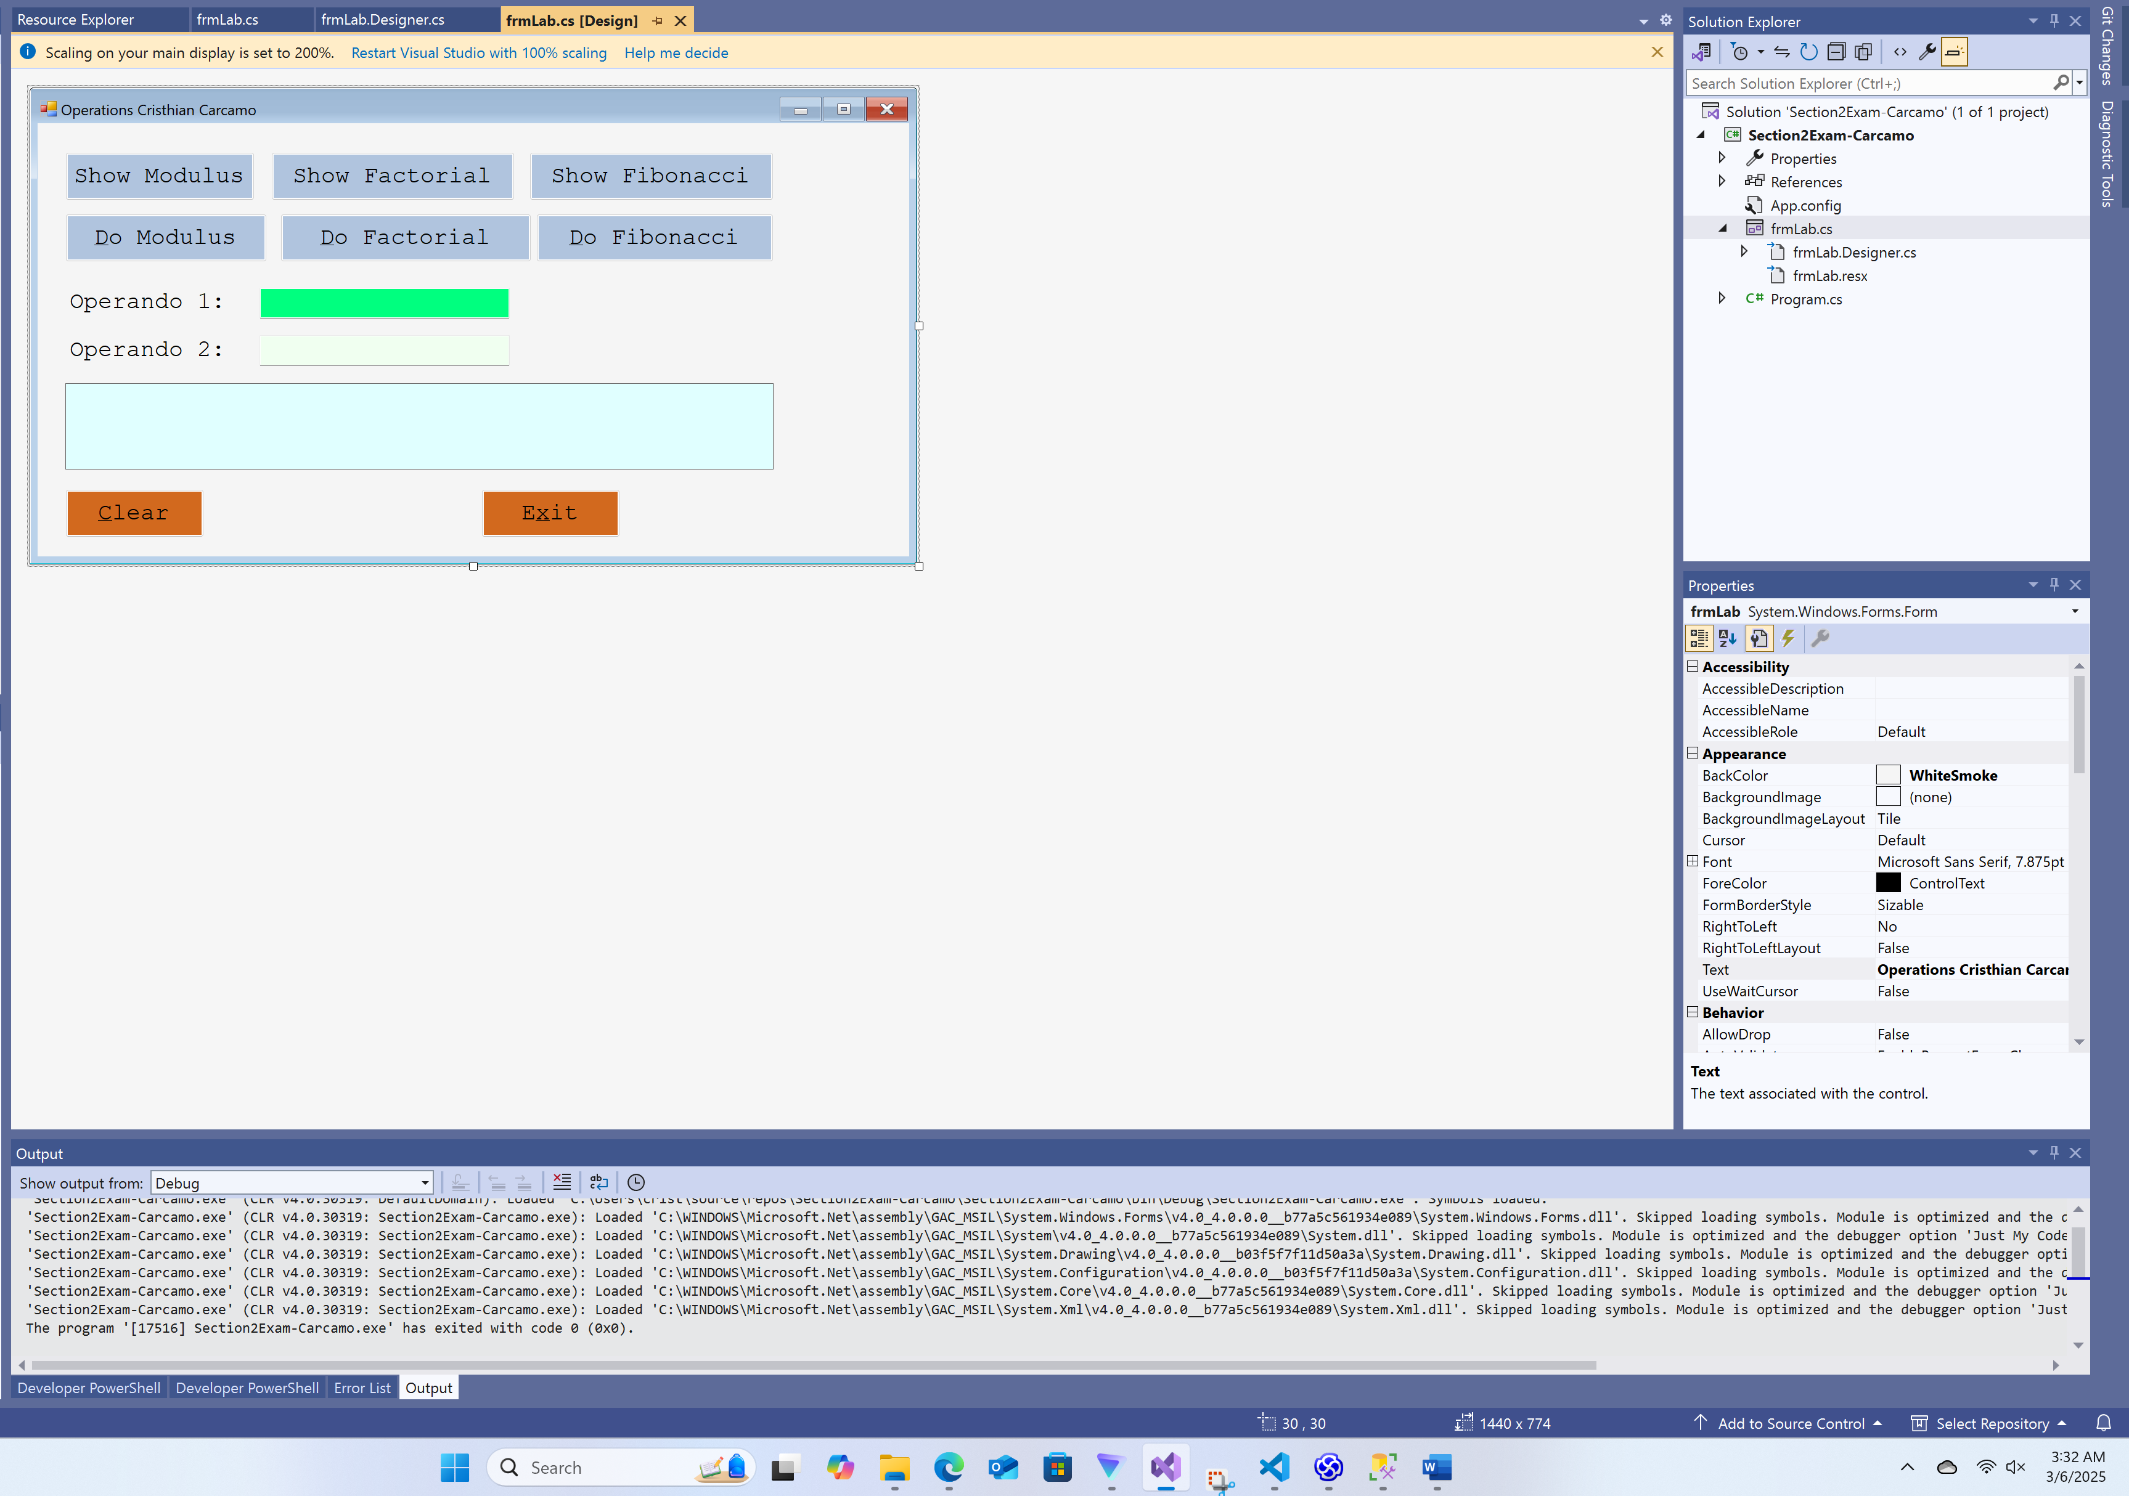

While running

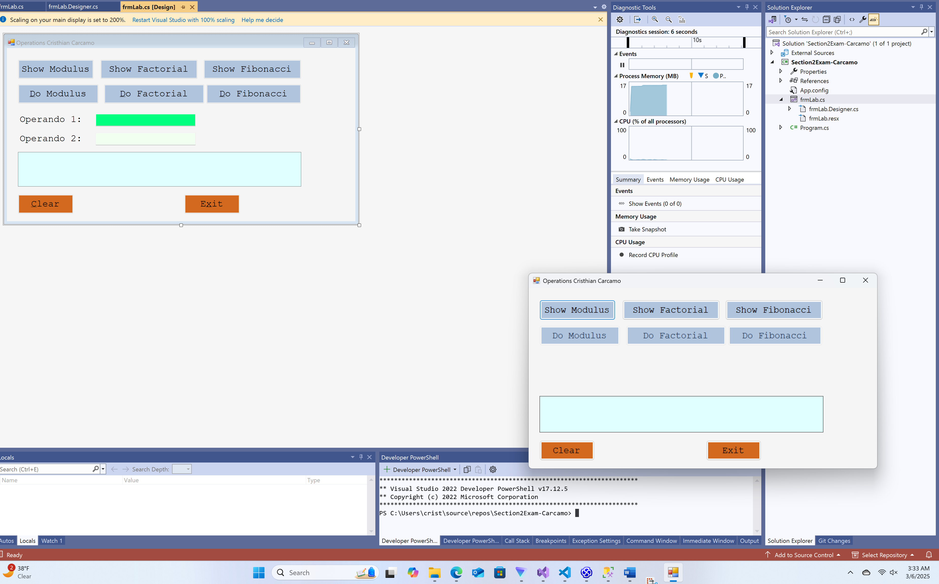

2021 % 13

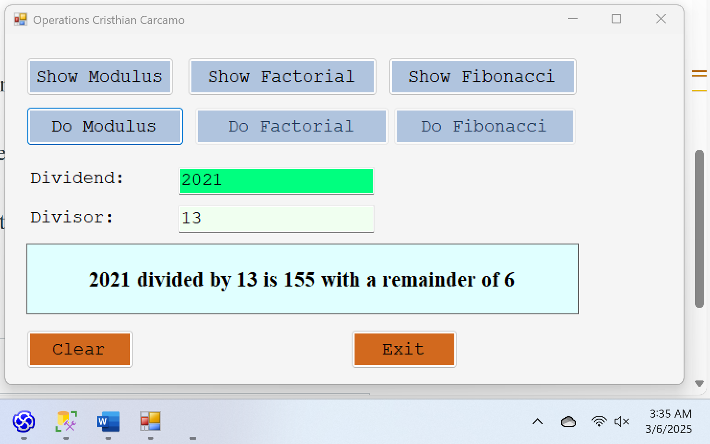

100,256 % 256

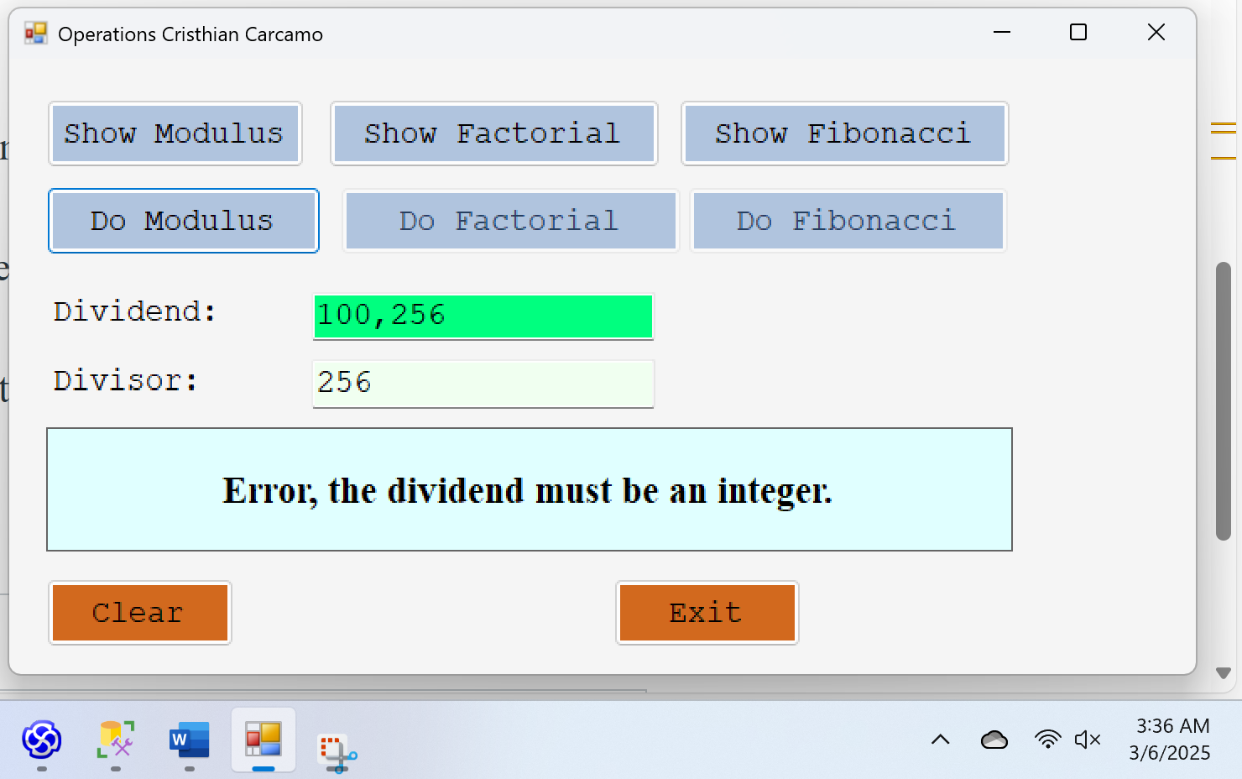

13

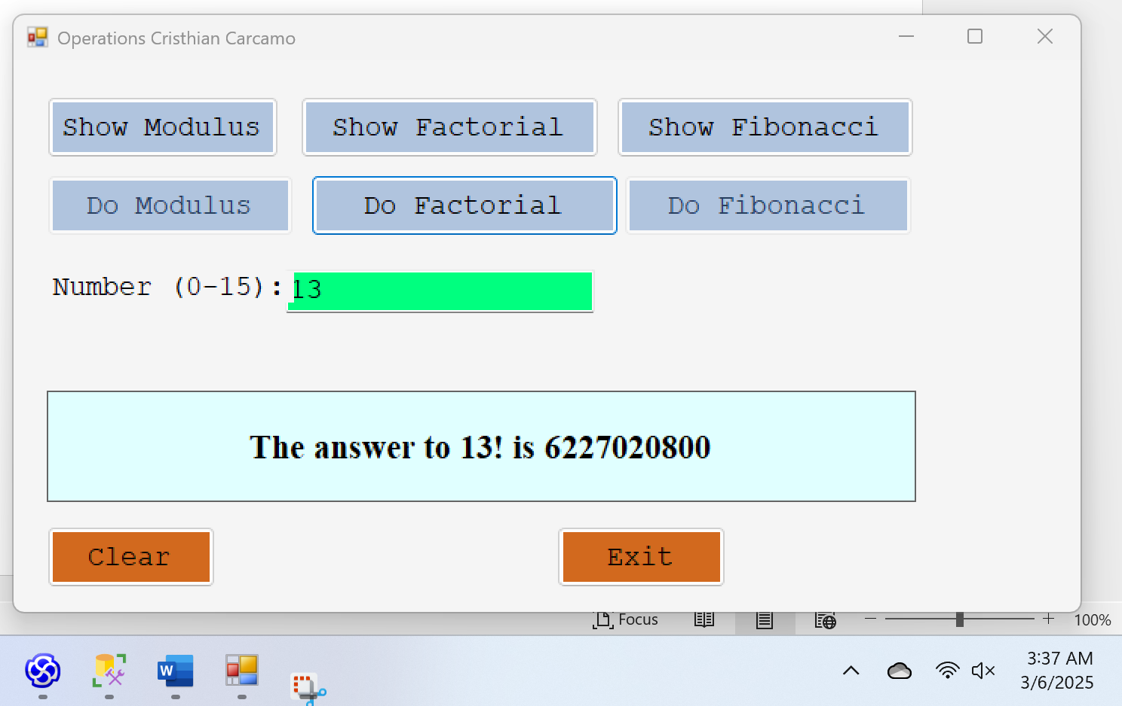

7

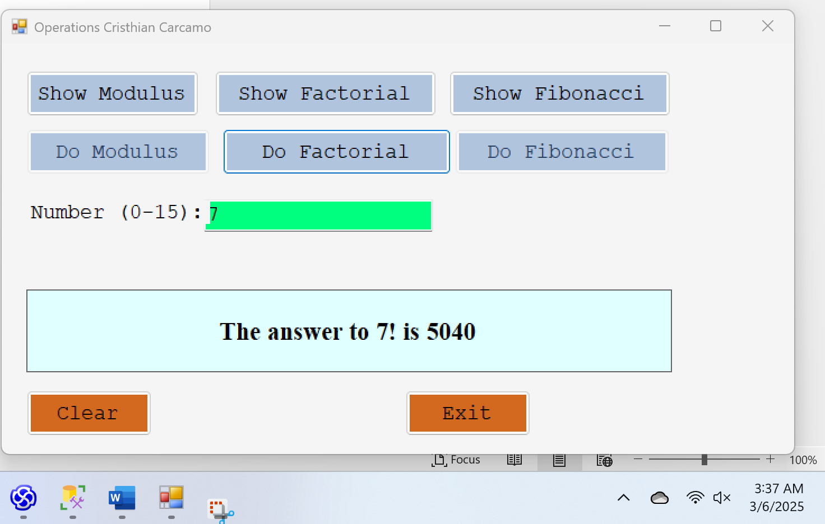

8

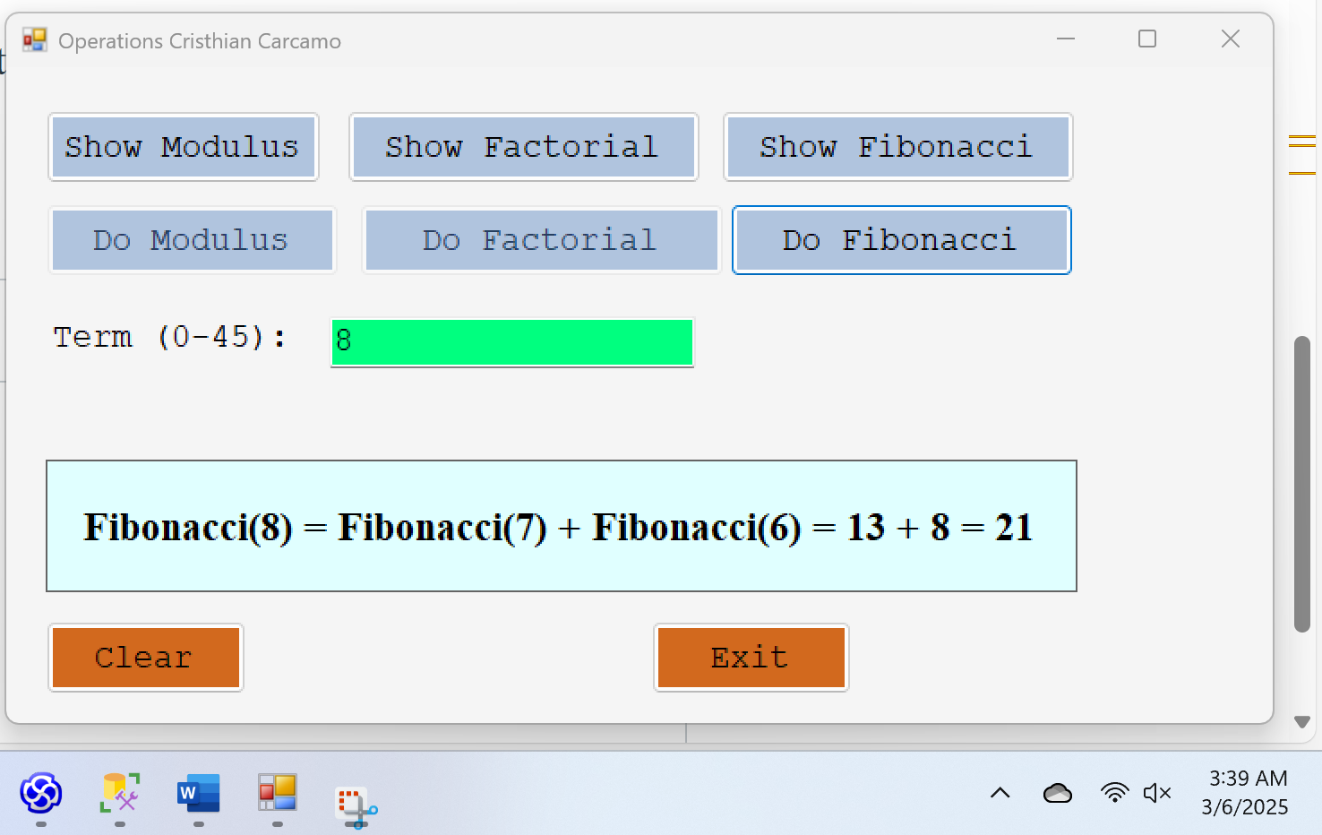

75

